**

**Welcome to the 2023 Club Car GMA NZ Summit**

**“Partnering beyond the Green”**

**August 27,28, 2023**

**Boulcott’s Heritage Golf Club, Lower Hutt**

**Delegates’ Registration Form**



**

**Delegates’ Registration Form**

Please return this completed form by email to:

Des Topp – Golf Managers Association of New Zealand

T: +6421392007 E: [eo@gmanz.co.nz](https://d.docs.live.net/a72c106d8ba7d744/DJT/GMANZ/GMANZ%20Conference%202021%20-%20Auckland/Registration%20forms/eo@gmanz.co.nz)

GMA NZ/NZPGA PO Box 39 272, Howick, Auckland, 2145

**DELEGATE PARTNER**

**YOUR DETAILS**

Title (Mr. / Mrs. / MS etc.)

First name Surname

________________________________________________________________________________________________

Club/Company

Position

Dietary / Special Requests

*The Privacy Act 1993 requires that before we can publish your name, address, and any details in the list of delegates provided to sponsors, you must give your consent. Tick here if you* ***DO NOT*** *want your details to appear on a delegate list.*

**HOW DO WE CONTACT YOU:**

Club/ Company__________________________________________________

Postal Address __________________________________________________

Suburb, City & Postcode__________________________________________

Daytime & Mobile Number________________________________________

Email Address___________________________________________________

**MY REGISTRATION CATEGORY**

Delegate - member Delegate – non-member Delegate partner

Day guestMonday Club CarDinner Guest

**REGISTRATION FEES* DELEGATE DELEGATE**

GMA NZ Member (includesClub car Awards D $250.00 + GST

Extra delegate (includes Club Car Awards Dinner ) $250.00 + GST

Summit Club Car dinner guest $120.00 + GST

**PAYMENT OPTIONS**

**Total amount to be charged to my account: $.........................**

**Option 1: On Invoice:** Please forward an invoice to facilitate payment.

**Option 2: Direct Credit:**

**Account Name**: Golf Club Managers Association of New Zealand

**Account No**: 02-0404-0203840-000

**Transaction Date:** ___________________________ **Reference Used:**__________________________

**Option 3 : Credit Card**: I authorise the organiser to debit $ ……………………from my credit card plus a 3% transaction fee.

**Card Number:**

**Card Type**:_______________________  **Expiry Date:** ________________________**CSV Number:**__________

**Name on Card Signature:**

**ACCOMMODATION:**

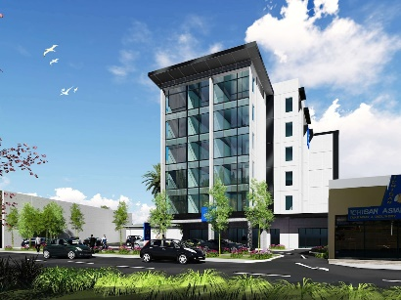

The Sebel Lower Hutt, as the preferred accommodation supplier, provides a 15% dynamic rate code for the conference dates. The 15% dynamic rate code discount can be actioned by Summit delegates by directly booking from our hotel website.

[GMA NZ Summit 2023 - Accor Meetings & Events (accorevents.com)](https://accorevents.com/offers/gma-nz-summit-2023)

**Please note**: The room rates are dynamic in nature, 15% discount will be applied to the rates at the time of you making the reservation.

**TERMS & CONDITIONS**

1. All prices are in New Zealand dollars and are exclusive of NZ GST which will be applied at 15%.
2. Payment by credit card incurs a 3% card fee.
3. Registration will be confirmed in writing, upon receipt of the total payment due.
4. Cancellation is required by written notice to the Organiser and will result in the following:
5. Prior to **20th July 2023,** a full refund on the Registration Fee will be made less an administration fee of NZD $75.00 + GST. After **20th July 2023,** no refund will be provided for any / all Registration Fees
6. Accommodation is subject to availability and is the delegates responsibility.
7. The Host and Organiser reserve the right to alter the programme if required.