|  |  |
| --- | --- |
| |  | | --- | |  | |

|  |  |
| --- | --- |
| |  | | --- | |  | |

|  |  |  |
| --- | --- | --- |
|    |  |  | | --- | --- | | |  | | --- | | **Golf Managers Association of New Zealand and Club Car Summit**  **Lower Hutt**  **August 27-28, 2023**  **“Partnering beyond the green”**  **Programme**     | | |

**Our Purpose**

***“Partnering beyond the green”***

It is the obligation of the Golf Managers Association of New Zealand (GMA NZ) to provide the best outcomes for New Zealand’s Golf industry by bringing golf club managers together in a collaborative manner to discuss opportunities to grow the game.

Working in our own silos will not have the impact needed to survive in what is a highly competitive sporting-based environment. We need to be able to work together across both our sectors if we are going to have a real impact.

The secret about collaborating and cross sectoral work, is it requires us to work in new and different ways. It can be hard, and it requires us to give things up, or to renegotiate loyalties.  It requires us to care about the things that our collaborators care about. But when it works, it can be powerful.

We think it is important that we share what we are learning.  We are not great at collaboration in Aotearoa New Zealand and the challenges we need to navigate are going to force us to do more and more of it.  So, if we are going to get better at it, let us learn from each other.

We look forward to sharing further details of the planned Summit as we progress our planning.

Richard Nauck PGA

President

GMA NZ

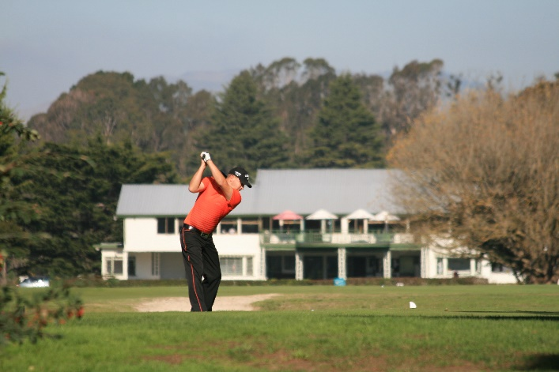

**Organising committee:**

Event Manager: Des Topp Executive Officer Golf Managers Association of New Zealand

Organizing Group: Amy Sidford GM Boulcott’s Farm Heritage Golf Club.

**Location:**

Lower Hutt

**Venue:**

Boulcott’s Farm Heritage Golf Club

Accommodation:

Sebel Hotel Lower Hutt - Accommodation to be booked by delegates direct.



The Sebel Lower Hutt, as the preferred accommodation supplier, provides a 15% dynamic rate code for the Summit dates. The 15% dynamic rate code discount can be actioned by Summit delegates by directly booking from our hotel website.

[GMA NZ Summit 2023 - Accor Meetings & Events (accorevents.com)](https://accorevents.com/offers/gma-nz-summit-2023)

**Please note**: The room rates are dynamic in nature, 15% discount will be applied to the rates at the time of you making the reservation. Breakfast is extra.

**Programme**

**Day 1 Sunday 27 August 2023**

**Summit Golf Day**

Event managed by Boulcott’s Heritage Farm Golf Day

Entry fees payable to the Golf Club



Event managed by Boulcott’s Heritage Farm Golf Day

Entry fee payable to the Golf Club

**Day 2 - Monday 28 August 2023**

GMA NZ “Partnering beyond the green” Summit.

Summit Dinner and Awards TBA

**Summit Registrations**

Location: Boulcott’s Farm Heritage Golf Club

**Principal Partner:**

**Golf New Zealand**

**Platinum Partner:**

**Club Car** - **Power Turf**

Gold Partners:

**Dot Golf**

**Parkland – Toro**

**Asahi**

**Silver Partners:**

**Dot Golf**

**N3**

**FlexiPlay – NZ Specialized Coatings**

**GMA NZ Summit Club Car Dinner and Awards**

MC Ross Bond – General Manger Shandon Golf Club

**Summit Timetable and Venue**

**Venue:** **Farm Café Boulcott’s Farm Heritage Golf Club**

**Day one**

|  |  |  |
| --- | --- | --- |
| **Sunday 27, August 2023** | | |
| 12 noon | Tee-off -rolling start |
| 5.00pm | Prizegiving and refreshments |

**Day two**

|  |  |
| --- | --- |
| **Monday 28 August 2023** | |
| 8.00 am | Registration opens |
| 8.00am - 8.15am | **Opening addresses**  **Richard Nauck CCM** Chair GMA NZ General Manager Titirangi Golf Club  **CEO** GolfNZ  **Dean Murphy CEO** Dot Golf Ltd |
| 8.15 am – 9.15 am | **Liz Perkins – Perkins Coaching**  **Facilitator**  *The Importance of Building a Positive Work Culture for Ensuring Long-term Staff Retention.* |
| 9.15am – 10.15am | **Lyncia Podmore – You Coaching Ltd**  **Facilitator**  *A Balancing Act: Juggling my Board and Staff Responsibilities with my Home Life* |
| 10.15 am – 11.15 am | Morning tea |
| 11.15 am – 12.15 pm | **Kerry Topp – The KDT Collective**  **Facilitator**  *Unleashing the Power of Artificial Intelligence: Exploring the Advantages and Opportunities of Chatbots in Today's Golf Club Management World* |
| 12.15 pm – 1.30 pm | Lunch |
| 1.30 pm – 2.30 pm | **Jeff Blunden – GBAS Melbourne**  **Facilitator**  *Maximizing Performance: Understanding Universal Key Club Performance Indicators for Effective Club Management* |
| 2.30pm – 3.00pm |  |
| 3.00pm – 4.00pm | **John Spraggs Course Superintendent – Royal Wellington Golf Club**  **John Woodham – Chief Executive Power Turf**  **Toro**  **Facilitator Leo Barber: GM Paraparaumu Golf Club**  *The use of Artificial Intelligence to revolutionize turf management.* |
| 4.00 pm – 5.00 pm | Panel discussions - details below |
| 5.30 pm – 6.30 pm | Hospitality Hour |
| 7.00 pm | **GMA NZ** Summit **Club Car** Dinner |
| 8.30 pm | GMA NZ **Club Car** Club Manager of the Year Award |
| 8.40 pm | Guest speaker |
| 11.00 pm | Close |

**Panel discussions**

|  |  |  |
| --- | --- | --- |
| 4.00 pm - 4.15pm | *Engaging young people in golf* | **Claire Beuvink** – Golf NZ |
| 4.15pm - 4.30pm | *Cost saving options for consideration* | **Ally Shadbolt** – n3  **Darcy Pye**-n3  **Mike Hadley** - GM Christchurch Golf Club |
| 4.30pm-5.00pm | *Hospitality tips and treats* | **Rydges Hotel** |
| 5.00pm – 5.30pm | *Technological advances in the golf industry* | **Matt Smith** – Dot Golf  **Chris Davies** CCM – GM **Remuera Golf Club**  **Richard Nauck** CCM – GM Titirangi Golf Club |

**Speakers**

**Liz Perkins**

"The Importance of Building a Positive Work Culture for Ensuring Long-term Staff Retention.”

**Kerry Topp**

"Unleashing the Power of Artificial Intelligence: Exploring the Advantages and Opportunities of Chatbots in Today's Golf Club Management World"

**Lyncia Podmore**

" Balancing Act: Juggling my Board and Staff Responsibilities with my Home Life”.

**Jeff Blunden**

"Maximizing Performance: Understanding Universal Key Club Performance Indicators for Effective Club Management"

**John Spraggs Course Superintendent – Royal Wellington Golf Club**

**John Woodham – Chief Executive Power Turf**

**Toro**

"Using Artificial Intelligence to revolutionize turf management.”

**Dinner speaker**

**Koro Carman**

**Managing Director**

**Green Waste Products**

Hard out golfer, Entrepreneur, Storyteller

“The story behind the mission to turn gorse into golf tees”.