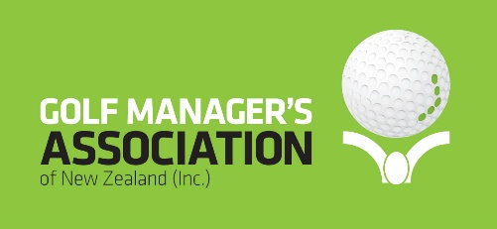

The Golf Managers Association of New Zealand (GMANZ) comprises club managers and administrators, staff, board chairman and members of the wider golf industry community whose aims are to assist management and boards with everyday operational aspects of their clubs through the provision of:
- networking amongst local and international associates
- shared experiences and information
- forums for the exchange of views

GMANZ also delivers the Club Management Association of America (CMAA) educational programme in NZ which providing vital information needed to increase members’ knowledge of club management.

Membership Benefits

Essentially, we help our members in 4 different ways:
• We provide networking opportunities.
• We promote and market golf as a whole.
• We help save golf clubs money.
• We provide golf clubs with relevant information, resources, industry insights and tools.
Events & Networking - Celebrating, connecting, and learning.
Our events keep your club moving!
• Regional events. Our regular membership events across 6 regions are a unique opportunity for club management to connect for one-on-one networking.
• Key events –Summits, forums, conferences, awards dinners & more. Each year GMANZ brings the industry together at key events to learn, network and grow club business.
• Regional branch activities... Get involved with one of our 6 regional branches. A great way to network your club and service.
• Networking access to local GMANZ members
• Career Services, job notice board, remuneration advice, employment agreement advice
• Global Networking Opportunities
• Industry Best Practices
Marketing & promotion
Getting your club out there can be hard work. Let us give your club business a boost.
• Free promotion of your club online through GMANZ channels plus opportunity to promote a special member offers
• Advertise at discounted rates through the GMANZ newscasts
• To promote your club brand and your commitment to the industry, GMANZ offers a number of key sponsorship opportunities………… summits, regional forums, golf days and more.
• Members also have the opportunity to partner with the GMANZ with extensive co-marketing and promotion opportunities.
Advisory service
• Management advice on regulatory matters such as Health & Safety, Alcohol Licensing, Food safety requirements
• Management advice on governance matters – constitutions, employment etc
• Management advice on trading matters - Point of Sale, margins etc
• Benchmarking against other clubs of similar size
• Information on industry issues such as working conditions and salary standards
• Reciprocal membership rights to Club Management Association of America and Golf Management Australia
Education
• Professional development seminars and webinars - can be accessed from anywhere.
• World class BMI education programme recognized internationally.
Save!
Our exclusive member offers, and discounts include:
• BMI Education courses at member pricing
• GMANZ Conferences and Summits at member pricing
• GMANZ 1 and 2-day educational forums at member pricing
• GMANZ on-line educational workshops at no charge
• Apex Insurance packages for golf clubs at member pricing
• Office Products Depot office stationery and supplies at member pricing
• Intuition HR Health and Safety and Human Resources support at member pricing
• XERO Accounting and Payroll software at member pricing
• Special pricing from leading golf course equipment suppliers
• Special pricing from leading food and beverage supply houses
• Special pricing from leading utility supply companies
• Special pricing from leading finance houses for capital item purchasing or leasing
Relevant information
Keep your finger on the pulse of the golf club industry.
• GMANZ newscasts keep you up to date with key national and international industry insights, trends, research, growth, and statistics.
• Free 24/7 advice line and mentoring ….. can assist with employment relations, legal, compliance and financial matters and more.
• The right information and resources to run your club business effectively is also included as part of your membership.

To apply for membership of the Golf Managers Association of New Zealand please click on the link https://www.golfmanagers.co.nz/members/apply.html

