

Newsflash No 1 – April 2023

Please circulate to:
Club President, Club Chair, and Club Board Members.
Club General Manager, Manager, Club Administrator,
PGA Professional, Golf Operations Manager, Course Superintendent,
Food and Beverage Supervisor

In this issue we cover
- GMA NZ – Education Programme 2023
BMI Joe Perdue Certification Review Course – Apr 12-14 and May 22-24, 2023
BMI General Manager/COO Course 1-5 May 2023
BMI Club Management – 19-23 June 2023
BMI Food and Beverage Management – 24-28 July 2023
BMI Leadership Principles 1-5 May 2023
- GMA NZ Summit August 28, 2023, Lower Hutt – “Partnering beyond the green”
- GMANZ Resource Centre
GMA NZ 2022 - Results of Wages and Salary Review.
- GMA NZ Branch news
- Branch forum programme
- GMA NZ Golf Club Executive Recruitment Service
Vacancies
General Manager – Howick Golf Club
Operations Manager – OnPar Limited
Golf Operations Assistant – Royal Auckland and Grange Golf Club
Golf Retail Assistant - Royal Auckland and Grange Golf Club
Course Superintendent – Maungakiekie GC
Course Superintendent – Rotorua GC
Course Superintendent – Karori GC
Thank you - Sponsors

Good afternoon.

The thoughts of the Board of Golf Managers Association are with the managers, staff and members of those clubs so devastatingly damaged by the effects of Cyclone Gabrielle. In many instances the recovery process will be long and arduous and a drain on staff and finances.
Stay strong and please communicate with the Association if in need. We are here to help.

All the best,

Richard Nauck
President,
GMA NZ



The Golf Managers Association of New Zealand’s stated goal is to improve the standard of club management here in NZ through continuing education and by offering the Club Management Association of America’s internationally recognized BMI Educational Programme, which leads to Certified Club Management (CCM) status, to its members.

2023 BMI Educational Programme
- BMI Club Management – Feb 13-17, 2023. Completed
- BMI General Manager/ Chief Operating Officer – May 1-5, 2023.
- Click here to register
- Click here to view the course curriculum, timetable and case study
- BMI Leadership Principles –.
- BMI Joe Perdue Certification Review Course and BMI examination – April 12-14, 2023, and May 22-24, 2023
- BMI Club Management – 19-23 June 2023
- Click here to register
- Click here to view course curriculum and timetable
- BMI Food and Beverage Management – 24-28 July 2023
- Click here to register
- Click here to view the course curriculum timetable and case study
- BMI Leadership Principles – Next course 2024
Managers who participate in the BMI Career Development Programme receive a host of benefits including:
- Making contact with industry experts.
- Networking with fellow managers who manage the most innovative and prestigious clubs across the country.
- Discussing new ideas that can be implemented in your own club.
- Receiving instruction from the nation's finest club management educators
- Visiting and touring other club operations; and
- Growing not only as individuals, but as an integral part of our national club network.
We look forward to your receiving your registrations and ask that you make contact if you require further information - eo@gmanz.co.nz

“The professional and club-industry focused BMI programme was a no-brainer to get involved with. The competencies covered are club specific with everyday relevance to our club/working environment.”
Hugo Littlejohn General Manager Maungakiekie Golf Club


Dates: August 27, 28, 29 2023
Venue: Lower Hutt Events Centre, Lower Hutt

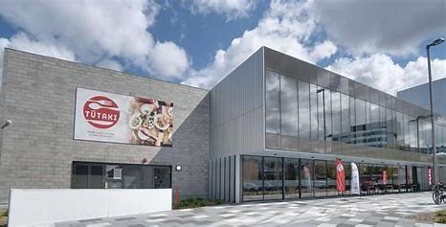
The Lower Hutt Event Centre

Programme
Day 1 - Sunday 27 August 2023
From 10.30 am | Golf Day | Boulcott’s Farm Heritage Golf Club
12,00 pm | Golf – Shotgun start | Boulcott’s Farm Heritage Golf Club
5.00 pm | Golf Prizegiving | Boulcott’s Farm Heritage Golf Club
5.30pm | Trade Show Opens | Trade Exhibition Hall Lower Hutt Event Centre
6.00pm -8.00pm | Meet and greet | Trade Show Opens

Day 2 - Monday 28 August
8.00 am – 5.00 pm | Registration opens | Reception desk Lower Hutt Event Centre
8.00 am – 6.00 pm | Trade Show Opens | Trade Exhibition Hall Lower Hutt Event Centre
8.30 am – 10.30 am | Plenary Sessions | Hall 1 Lower Hutt Event Centre
10.30 am – 11.00 am | Morning tea | Trade Exhibition Hall Lower Hutt Event Centre
11.00 am – 12.30 pm | Plenary Sessions | Hall 1 Lower Hutt Event Centre
12.30 pm – 1.30 pm | Lunch | Trade Exhibition Hall Lower Hutt Event Centre
1.30 pm – 3.30 pm | Plenary Sessions | Hall 1 Lower Hutt Event Centre
3.30 pm – 4.00 pm | Afternoon tea | Trade Exhibition Hall Lower Hutt Event Centre
4.00 pm – 5.00 pm | Plenary Session | Hall 1 Lower Hutt Event Centre
5.00 pm – 6.00 pm | Hospitality Hour | Trade Exhibition Hall Lower Hutt Event Centre
7.00 pm | Conference Dinner | Hall 1 Lower Hutt Event Centre
9.00 pm | GMANZ /PGA Awards | Hall 1 Lower Hutt Event Centre
9.30 pm | Guest speaker | Hall 1 Lower Hutt Event Centre
11.00 pm | Close

Day 3 - Tuesday 29 August
8.00 am – 12.00 pm | Registration opens | Reception desk Lower Hutt Event Centre
8.00 am – 4.00 pm | Trade Show Opens | Trade Exhibition Hall Lower Hutt Event Centre
8.30 am – 10.30 am | Plenary Sessions | Hall 1 Lower Hutt Event Centre
10.30 am – 11.00 am | Morning tea | Trade Exhibition Hall Lower Hutt Event Centre
11.00 am – 12.00 pm | Plenary Session | Hall 1 Lower Hutt Event Centre
12.00 pm – 1.00 pm | Lunch | Trade Exhibition Hall Lower Hutt Event Centre
1.00 pm – 3.00 pm | Plenary Sessions | Hall 1 Lower Hutt Event Centre
3.00 pm – 3.30 pm | Afternoon tea | Trade Exhibition Hall Lower Hutt Event Centre
3.30 pm – 4.15 pm | Keynote speaker | Hall 1 Lower Hutt Event Centre
4.15 pm – 4.30 pm | Conference closing | Lower Hutt Event Centre

REGISTRATION FEES

Client | GMA NZ/PGA
Event | Conference
Dates | 27-29 August 2023
Participants | 230
Exhibitors | 40
Registration fees | Excl GST
Delegates - members - Early bird | $400.00
Delegates - members - Standard | $450.00
Delegates - non-members - Early bird | $450.00
Delegates - non-members - Standard | $500.00
Golf Day | $80.00
Extra dinner guest | $150.00
Extra golf guest | $80.00
Partners/Sponsors Fees
Platinum Partner -incl equipment display, 2 nights’ accommodation and dinner for 2 persons | $10,000.00
Gold Partner - incl equipment display 2 nights’ accommodation, dinners for 2 persons | $7,500.00
Silver Partner incl equipment display, dinner for 2 persons | $5,000.00
Trade exhibitors fees incl equipment display, dinner for 2 persons | $4,000.00
Trade exhibitors fees, incl table display, dinner for 2 persons | $1,000.00
To register you can click here

PRELIMINARY SPEAKER PROGRAMME

A PRELIMINARY LIST OF TOPICS TO BE COVERED BY OUR EXPERTS INCLUDES:
- Participation - product development, inclusion, females, juniors, and equal opportunity
- Technology - systems, business intelligence, coaching, education and innovation
- Customer centricity - experience, loyalty, service, and engagement
- Communication - strategy, communication, implementation, and success
- Governance – strategy, financial planning, benchmarking, diversity,
Watch this space as we confirm our speakers.

So yesterday we made a loss, but we got rich!
I could see the weather forecast - snow, rain, wind, freezing temperatures. So why even open the van, it’ll be dead along the river?
There’s a few reasons. But first, here’s how the day shaped up financially…
Revenue = £275
Value Added Tax payable = £45
Barista wage (8 hours) = £115
Owner wage (3 hours) = £0
Coffee / milk / bakes costs = £100
Disposables costs: £10
Fixed operating costs = £10
Net loss = -£5
But here’s the thing. Even though our coffee sales were way down, we earned something WAY MORE valuable than profit…Respect & Consistency.
In street coffee, if customers aren’t sure whether you’ll be there they won’t take the risk - they’ll head to their local brick & mortar cafe. They need to guarantee their effort with a coffee fix.
Dear Coco’s main currency is Dependability. So we use days like yesterday to trade our stock on the Credibility Stock Exchange. Yes we took a hit in the back pocket - but our stock price went up.

Golf Club - Wage and Salary Survey
Click here to view the results the Golf Club Salary and Wages Survey as at 1 Sept. 2022.
Base salary and wage figures quoted. Figures quoted expressed as $000’s.
----------------------------------------------------------------------
Golf Balls Leaving Property Resources

Please see links below:
https://www.golf.co.nz/resource-detail/golf-balls-leaving-property-nuisance-and-negligence
https://www.golf.co.nz/resource-detail/negligence-nuisance-case-studies
https://www.golf.co.nz/resource-detail/noise-complaints

Executive Recruitment Service

The Golf Managers Association of New Zealand (GMA NZ) is now offering an Executive Recruitment Service to its members at attractive rates .GMA NZ will connect your Club with skilled professionals who are looking for permanent opportunities and streamline the process to ensure that your recruitment needs are met.
Finding the right person for a role is more than just a skills match. Combining many years of club management knowledge and a high-calibre level of member service driven to deliver on your hiring objective, your Club will benefit from GMA NZ personalised talent identification solutions.
The industry specific, end-to-end service, conducted in partnership with selected club board personnel includes:
- Composing Job Descriptions for management positions across the entire golf club sector
- Creating an appointment process timeline
- Managing the vacancy advertising campaign
- Interviewing candidates
- Selecting and managing short lists
- Arranging final interviews
- Providing benchmarked salary packages
- Negotiating and finalising salary packages
- Preparing employment agreements
- Attractive rates for GMA NZ members
Recent appointments:
Kelly Brenton – GM Te Puke Golf Club
Clinton Butler – GM Rotorua Golf Club

For a confidential golf club executive recruitment proposal contact:
Des Topp
Executive Officer
Golf Managers Association of New Zealand
W: www.golfmanagers.co.nz
E: eo@gmanz.co.nz
T: 021 392 007

Testimonial:

On behalf of the selection committee, I would like to sincerely thank you for your assistance in the recruitment process. It has been very successful, and we will not hesitate to use GMANZ again for our recruitment.

I also look forward to a strong continued relationship with you and GMA NZ in regard to staff development and education.

Craig McCulloch
Chairman
Te Puke Golf Club
December 2, 2022

GMA NZ News

GMA NZ Northern Branch – Matt Owen reporting
Next meeting planned May - details to follow.

GMA Bay of Plenty Branch – Mike Williams reporting
29th May 2023 10.30am start Omanu Golf Club
Topics for discussion
- Omanu Golf Club course redevelopment tour and process
- Dot Golf update – Mat Eagleson
GMA NZ Central Branch – Amy Sidford
Next meeting planned June - details to follow.
Topics for discussion
- Clubhouse hospitality and trends

GMA Northern South Island Branch – Mike Hadley
Next meeting planned Wednesday 22 June - details to follow.

GMA Southern South Island branch – Shelley Duncan
Details to follow.

Job board
Golf Operations Positions
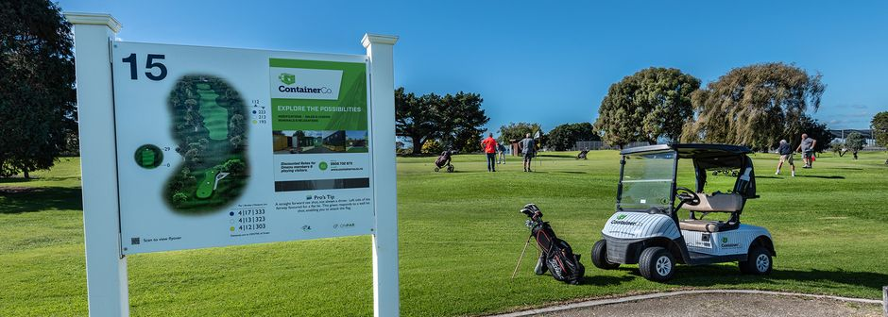
On Par Limited - Operations Manager
Click here to view advertisement.
________________________________________________-

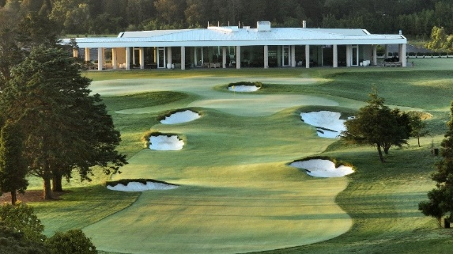
Royal Auckland and Grange Golf Club Golf Operations Assistant
Click here to view advertisement

Royal Auckland and Grange Golf Club Retail Assistant
Click here to view advertisement
______________________________________________________

Course staff

Maungakiekie Golf Club - Course Superintendent
Click here to view advertisement
____________________________________________

Karori Golf Club - Course Superintendent
Click here to view advertisement.
________________________________________________________________

Rotorua Golf Club Course Superintendent
Click here to view advertisement
____________________________________________

Karori Golf Club – Greenkeeper – 2ic
Click here to view advertisement
_____________________________________________
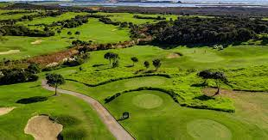
Carrington Golf Course – Greenkeeper
Click here to view advertisement.
_______________________________________________________________

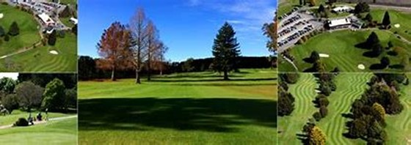
Te Puke Golf Club – Greenkeeping Labourer
Click here to view advertisement

 | Principal Sponsor
 | 
 | Platinum Sponsor
 | 
 | Educational Supporters
 |  | 
 | Gold Sponsors
 |  | 
 |  | 
 | 
 | Silver sponsors
 | 
Bronze sponsors

Remember to go to www.golfmanagers.co.nz for all Association information

Kind regards

Des Topp
Executive Officer
Golf Managers Association of New Zealand P O Box 39 272, Howick, Auckland 2145
+64 21 392 007 II eo@gmanz.co.nz II www.golfmanagers.co.nz II https://www.facebook.com/golfmanagers/


The Golf Managers Association of New Zealand Inc takes your privacy seriously and your details will not be passed on to any other organisation. Click here to read our full privacy statement.
CAUTION: This electronic email message and any attached files contain information intended for exclusive use of the individual or entity to whom it is addressed and may contain information that is proprietary, privileged, confidential and/or exempt from disclosure under New Zealand law. If you are not the intended recipient, you are hereby notified that any viewing, copying,disclosure or distribution of this information may be subject to legal restriction or sanction. Please notify the sender, by electronic mail or telephone, of any unintended recipients and delete the original message without making copies.

